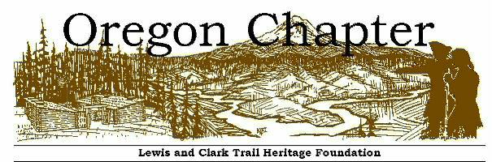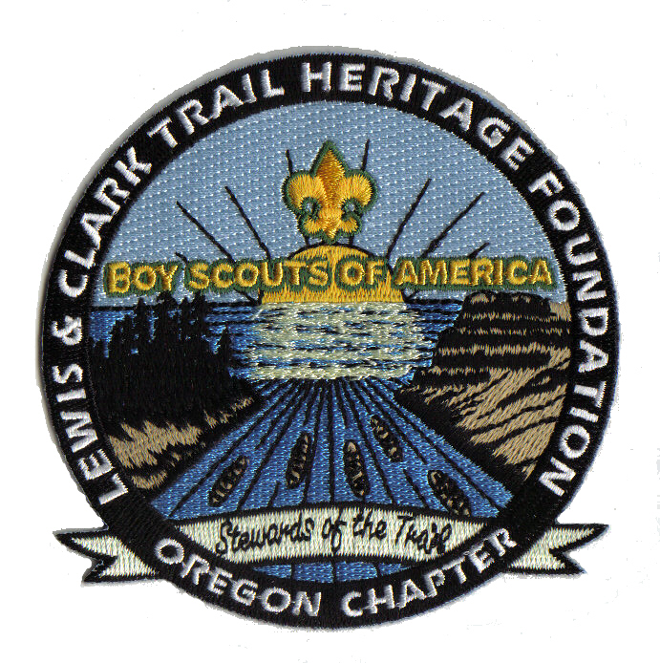

Details on Oregon Badge Requirements

OREGON CHAPTER COMMEMORATIVE AWARD PATCH

LEWIS AND CLARK TRAIL HERITAGE FOUNDATION, INC.

As “Keepers of the Story-Stewards of the Trail,” the Lewis and Clark Trail Heritage Foundation, Inc. provides national leadership in maintaining the integrity of the Trail and its story through stewardship, scholarship, education, partnerships and cultural inclusiveness. The Oregon LCTHF Chapter undertakes this mission in the Pacific Northwest in collaboration with the Washington and Idaho chapters.
The Lewis and Clark Trail in Oregon mostly followed the Columbia River, but now we can travel nearby public highways marked occasionally with distinctive brown road signs showing the captains pointing the way. Additionally, the Oregon Chapter has prepared an inventory of important historic markers, public art and specific locations important to the story (see http://or-lcthf.org/). Several public and tribal museums feature exhibits of historical items like those the Corps of Discovery might have encountered during that time period. Examples include the Columbia Gorge Discovery (http://www.gorgediscovery.org) in The Dalles, the Columbia Gorge Interpretive Center in Stevenson, WA (http://www.columbiagorge.org/), Oregon Historical Society (which holds several items carried by the Expedition but not always on display), and the new Lewis and Clark National Historic Park which incorporates a number of important sites in the Seaside, Astoria, and Ilwaco areas (particularly Fort Clatsop and the Lewis and Clark Interpretive Center (sometimes known as Cape Disappointment) in Ilwaco (http://www.nps.gov/lewi/index.htm). For persons interested in viewing copies of the same materials Lewis and Clark carried with them, and rare early editions of Lewis and Clark journals that were published in later years, contact the Archives at Lewis & Clark College (dme@lclark.edu) .
The Oregon Chapter wants to encourage youth organizations to learn more about the Lewis and Clark Expedition by offering an embroidered patch. The first patch was made specifically for the Boy Scouts of America and can be earned by Cub Scouts, Boy Scouts, Varsity Scouts, Explorers and Venturers. Requirements to earn this patch follow and should be completed with certification by an adult leader. An application form is attached. We are also hoping that school children and other youth organizations will want to work on these requirements as well and for those young persons, a special patch will be created. Some requirements are specific to Scouting, but others will work for all youth. For non-BSA organizations, teachers and youth leaders can act as counselors and sign off that the young people have completed the requirements and kept their journals. Other Oregon-based organizations who share our interest in youth learning first-hand about Lewis and Clark include the Historical Outreach Foundation (utilizing volunteers formerly representing the Oregon National Guard), and the Living History Association whose members frequently conduct historical re-enactments. Cooperating partners include the National Park Service, Wisdom of the Elders and tribal organizations.

Requirements
Requirement #1 all participants
Visit at least two of the following Lewis and Clark historical sites in Oregon or in nearby Washington locales. Keep a journal of your visits. Record the sites visited, location, date and the date or dates which Lewis and Clark were at or near these sites. Also, draw a detailed map of the site in your journal. Record your feelings and impressions of the sites. Read the accounts of Lewis and Clark in their journals about the sites you have visited and where possible perform a service project while you are there (such as clean up of trash or a task site supervisors might suggest).

- Lewis and Clark State Park and Sandy River bird blind (near Troutdale, Oregon)
- Bonneville Dam – Columbia Gorge
- Waud’s Bluff – Willamette River (near Terminal 4, Port of Portland)
- Rock Fort – The Dalles, Oregon
- Fort Clatsop – Astoria, Oregon
- The salt works – Seaside, Oregon
- Clark’s View (Hiker’s Camp) at Tillamook Head and Les Shirley Park, Cannon Beach, Oregon
- Hat Rock State Park near Umatilla, Oregon
- Cathlapotle Plankhouse at Ridgefield Wildlife Refuge, Ridgefield WA (docent needs to be present)
- Blue Lake Park, Nichaqwli Village monument (ask for DVD first)
- William Clark Park at Washougal, Washington
- Lewis and Clark Interpretive Center, Ilwaco Washington and Maya Lin fish cleaning station
- Long Beach Discovery Trail sculptures
- Columbia Gorge Interpretive Center in Stevenson, Washington
- Columbia Gorge Discovery Center near The Dalles, Oregon
- An approximate Corps of Discovery campsite location

Note to persons not living in Oregon: If you live beyond 300 miles of the Columbia River portion of the Lewis and Clark Trail through Oregon, then you may complete this alternative: Read the Lewis and Clark journals or consult historical narratives about the Corps of Discovery’s travel and challenges faced between October 1805 and April 1806. Describe in your journal two significant events that occurred during those months and relate those events to something that happened in your own local regional history or to an issue that is in the news today. Examples only: (1) How did the Corps take chances coming down the Columbia River from present-day Arlington to Portland? Were there some figures in history who took risks in your area? When is taking risks not always wise? What are examples of modern-day risk taking? (2) Journal-keepers describe immense salmon fisheries in 1805. What is the situation for salmon in the Columbia River system today? Are there fish or animals in your area that are being protected? How? (3) Some people believe the worst part of the Lewis and Clark journey was between November 7 and December 7, 1805. Why was this so? (4) The journals describe the polling of Corps of Discovery members on November 24, 1805. Why did the captains decide to do this? How might this foreshadow U.S. Constitution changes in the future? Italicized notes for items below are for persons living beyond Oregon.
Requirements

Requirement #2: complete any 2 of the following:
- Attend a meeting or activity of the Oregon (or any) chapter of the Lewis and Clark Trail Heritage Foundation. Talk to several people there and ask them questions you have about the Corps of Discovery. There is a wealth of knowledge within this group and they will be able to answer virtually any question that you might have. Be sure and write in your journal about the activity and the questions you asked and the answers received.

- Read the book Undaunted Courage or another book on Lewis and Clark. Write about your impressions of the book in your journal and 5 amazing things that you will remember most about the Corps of Discovery from reading this book.

- Watch the DVD “Lewis and Clark: Great Journey West,” a National Geographic Presentation or the DVD “Sacagawea: Heroine of the Lewis and Clark Journey” or the DVD “Technology of Lewis and Clark, the History Channel Presentation.” Record your reactions in your journal. Did you observe anything that didn’t make sense? (Hint: the National Geographic DVD “Great Journey West” shows the Expedition near the mouth of the Columbia River, but is the weather like their journals describe?)

- Hike the 6 mile Fort to Sea trail starting at Fort Clatsop. Record any wildlife that you encounter and make drawings of them in your journal. Did the Lewis and Clark journals describe any of these as well? (or comparable hike elsewhere)

- Research and plan a 5 mile hike along the Columbia River. Try to incorporate one of the campsites where the Corps of Discovery spent the night. Again make notations in your journal about the hike and the things you have seen. (Hint: many of the campsites are on the Washington side of the river. Why would that be? (or take a 5-mile hike in your region)

- Research the weapons carried on the Lewis and Clark Expedition (types of weapons, and supplies needed for them and to repair them). Write your findings in your journal. Hint: if you want to talk with one of the nation’s experts on this topic, contact Mr. Mike Carrick in Turner, Oregon (michaelcarrick@me.com) near Salem.

- Research the plants and animals that Lewis and Clark encountered in the Columbia River country. Make drawings of the animals, fish, and birds. Collect 5 samples of plants that they encountered while in Oregon. Hint: did you know the official Oregon and Washington state flowers was first documented for science by Meriwether Lewis? (or choose 5 specimens recorded by the Captains in your region)

- Research one of the Indian tribes encountered by Lewis and Clark in Oregon. Learn five words in their native language and describe their meaning in your journal. From the Lewis and Clark journals, describe some of their customs, diet, and how they interacted with the Corps of Discovery. What is the situation for this tribe today (government, economy, language preservation, legal status of tribe, number of tribal members). Find out what “ceded rights” means today. Note: If you are able to observe a pow wow or visit a reservation, that is a good thing to do. (or choose a tribe in your region)

- Earn the Boy Scout Indian Lore Merit Badge using tribes of the Columbia River as your focus. Research how Lewis and Clark felt about the tribes they met.

- Research the food that Lewis and Clark had access to in Oregon. Prepare a meal for your troop, patrol or family using comparable food items that you can find today (for example, you may need to substitute beef for elk).

- Visit the re-enactors at the salt works in Seaside, Oregon (typically on certain weekends in July and August). Interact with them, and then write a report in your journal on your experience including how to make salt from seawater, the importance of the work done there to the Corps of Discovery and why they might have chosen that particular location for this job. (or visit a re-enactment focused on Lewis and Clark or the fur trade era in your region; consider why salt was a priority)

- Study how the Corps of Discovery entertained themselves on the journey and re-create some of the music, games, and pastimes for a campfire or other gathering. Provide references from the journals. (Hint: don’t hurt yourself dancing on your head, an early version of break dancing)

- Research a member of the Corps of Discovery: choose one of the officers, soldiers, York (an African American slave), Sacagawea (wife and mother, hired with her husband to help translate with tribes), her baby Jean Baptiste Charbonneau, several hired helpers, or even Lewis’s dog Seaman). In your journal, describe how this team member contributed to the Expedition while in Oregon and what happened to that participant after the mission was accomplished. (Hint: one of the party later came back to Oregon and is buried near Jordan Valley)

- While attending or serving on staff at Camp Meriwether, make a presentation to a parent night about the time Lewis and Clark spent in Oregon and the comparisons you see between the Corps of Discovery and the Scout Law and Motto. How did the Corps of Discovery illustrate these values 100 years before Scouting was founded?
- Learn how to measure latitude and/or longitude (with and without a GPS) and compare the results. How did Lewis and Clark handle this requirement from Jefferson? See these websites:

http://www.pbs.org/weta/roughscience/series1/challenges/latlong/page2.html
http://www.lewis-clark.org/content/content-article.asp?ArticleID=1264
http://www.celestialnavigation.net/classroom.html

NOTE: Your journal will become a valuable keepsake of your experiences in regard to the Lewis and Clark Trail. In addition to a journal, you may wish to keep a scrapbook or notebook of materials, informational leaflets, notes and other materials you acquire as reference material for further public presentations. Be willing to share what you have learned with others during the third century of the legacy of Lewis and Clark. Who knows? You may make a presentation in honor of the 250th anniversary of the expedition in the years 2053 -2056.

Resources
Resources You Will Find Helpful
Following are some useful websites on Lewis and Clark in Oregon Country and you will probably uncover many more:
www.lewisandclark.org – This is the website for the National Lewis & Clark Trail Heritage Foundation, keepers of the story and stewards of the Trail.
www.or-lcthf - The official website of the Oregon chapter with maps of the Trail in our region and lists of many historic sites as well as public art and other items of interest that can be visited.
www.lewis-clark.org - This is probably the most comprehensive website of all.

Lewis and Clark Among Northwest Indians
Start your discovery about the people who already lived in our region before the arrival of Lewis and Clark in October, 1805 with this website: www.trailtribes.org
For information about specific Indian nations along the Columbia whose ancestors helped Lewis and Clark survive, go to these websites and learn their history as well as current events today:
http://www.clatsop-nehalem.com/ This is a small tribe working to be recognized by the U.S. Department of Interior. They were described many times when Lewis and Clark camped at Fort Clatsop and traveled to make salt at the Pacific beach.
http://www.chinooknation.org/ The Chinook people were also described by Lewis and Clark along the lower Columbia River. They, too, are not a recognized tribe in the eyes of the federal government, yet they have a growing membership. Their offices are in Chinook, Washington west of the Astoria Bridge on the highway to Ilwaco.
http://www.grandronde.org/ A number of Chinook people and tribes calling themselves the Kalapuya, Multnomahs, Clackamas and many others were confederated in 1855 with headquarters today at Grand Ronde, Oregon. Their “jurisdiction” today in Oregon roughly extends from the mid-Columbia to the coast and far down into the Willamette Valley drainage and Douglas County.
http://www.umatilla.nsn.us/ Relatives of the three tribes that make up this confederation were all mentioned by Lewis and Clark: Cayuse, Umatilla and Walla Walla. The tribe operates an excellent cultural institute (museum) just east of Pendleton off I-84.
http://www.warmsprings.com/ Relatives of today’s Warm Springs, Paiute and Wasco Indian tribes may have been among those who watched as the Corps of Discovery hauled their canoes and gear through the rapids in the mid-Columbia area from near The Dalles to Cascade Locks today.
http://www.nezperce.org/ The Nez Perce people fished as far south as Celilo Falls and Oregon City. And today they live in Wallowa Lake area all the way up into Idaho where their headquarters is in Lapwai
http://www.yakamamuseum.com/ The Yakama nation is comprised of some 16 tribes and bands whose descendants today live along the north side of the Columbia from the Cascades east. Their relatives likely were picking huckleberries around Mt. Jefferson and had just finished the major salmon harvest before Lewis and Clark first met them at the confluence of the Yakama and Columbia Rivers.

History of Patch
How This Commemorative Patch Originated

National representatives of the Lewis and Clark Trail Heritage Foundation (LCTHF) and the Boy Scouts of America (BSA) signed a Memorandum of Understanding to benefit both organizations in August 2007. In the January-February 2008 issue of “Scouting” magazine there was an article about the BSA partnership with the National Lewis & Clark Trail Heritage Foundation. To quote the article “The agreement will promote programs of awareness, education and stewardship between local BSA councils and the foundation’s 40 chapters throughout the country.” This agreement grew from efforts of the Lone Star Chapter in Woodlands, Tex. and local Cub Scouts. Members put together a program helping the cub scouts to earn activity badges and belt loops based on the history of Lewis & Clark. A den leader from their pack is quoted as saying “I learned as much as my son did, and the adults were moved by all that Scouting has in common with the Lewis & Clark expedition.”
Today’s youth will play major roles in preserving the history of the trail and the native people who helped Lewis and Clark succeed. Stewardship of this valuable Northwest legacy is a worthwhile goal we share with Boy Scouting and many other organizations serving young people.

Oregon Chapter Recognition Patch Program
Lewis & Clark Trail Heritage Foundation, Inc.

Application
I have completed the listed requirements and thus earned the Oregon Chapter’s Recognition Patch for experiencing and learning about Lewis and Clark’s time in Oregon country and the Indian tribes they met.
Name _____________________________________
(if scout, unit number) Pack _____/Troop ______ / Crew _____ /Post______
(if other organization: __________ )
Applicant’s Address____________________________
____________________________
Email and phone __________________________
__________________________
Please indicate which requirements were completed and date completed.
Number 1 – Required for all participants. Date ______________
Number _____ Date ______________
Number _____ Date ______________
Certified by: Name _______________________________
Relationship to applicant: ______________________________
Address _____________________________
_____________________________
Phone: ______________________________

Please attach sample pages of your Journal for each requirement (can send by email as copies will not be returned with the patch). If photos are submitted with identifiable persons, please attach authorization to disseminate on our Chapter website or in print materials)

Cost of Patch: $5.00. Make checks payable to Oregon Chapter, LCTHF. This covers the cost of the patch, materials and shipping.

Send money and form to: Ms. Ellie McClure, 17760 SW Cheyenne Way, Tualatin, Oregon 97062, 503-692-5489, email ellie.mcclure@gmail.com You may want to keep a copy of your application just in case.

